Steps to Upload and Install the IFIX
Problem
Creating a user on the virtual machine fails with an unknown exception after deployment of Db2 pattern.
Abstract
You might experience failures while creating the user from the Manage Operations screen after deploying the IBM Db2 with BLU Acceleration Pattern V1.2.9.0.
It fails with the following error message:
“OS_Node.XXXXXXXX.DB2_Server-Part: Failed because of unknown Exception”.
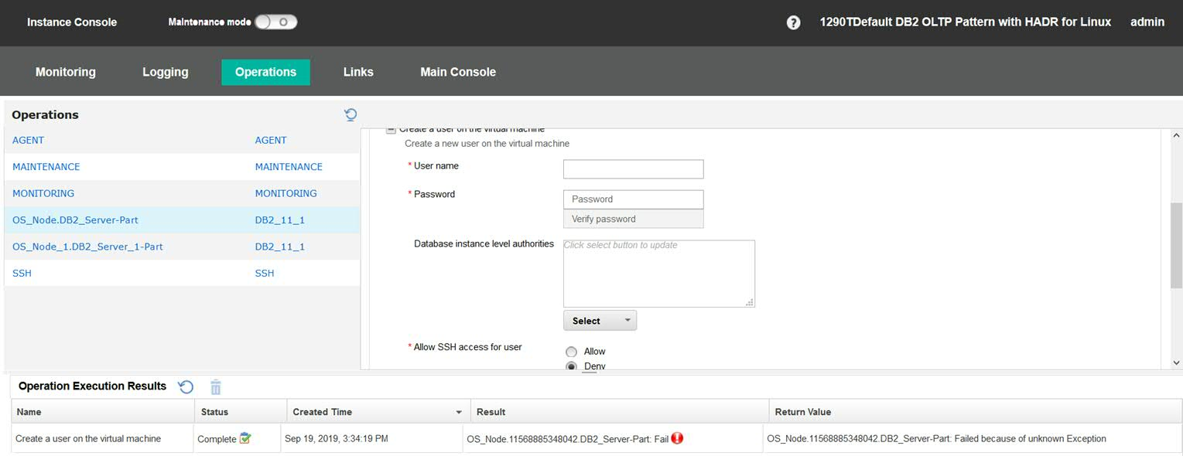
Content
Resolution
- Upload the IFix from IBM Cloud Pak System Menu CatalogEmergency Fixes.
- From the Instance console Go to ManageOperations and select and submit the IFix to install it.
Steps to upload the IFix:-
- From the IBM Cloud Pak System console, go to CatalogEmergency Fixes.
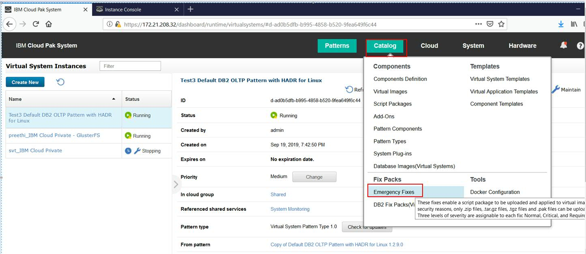
2) Click on “+” Image, provide the Emergency fix name and description in the opened popup. Then, click OK.
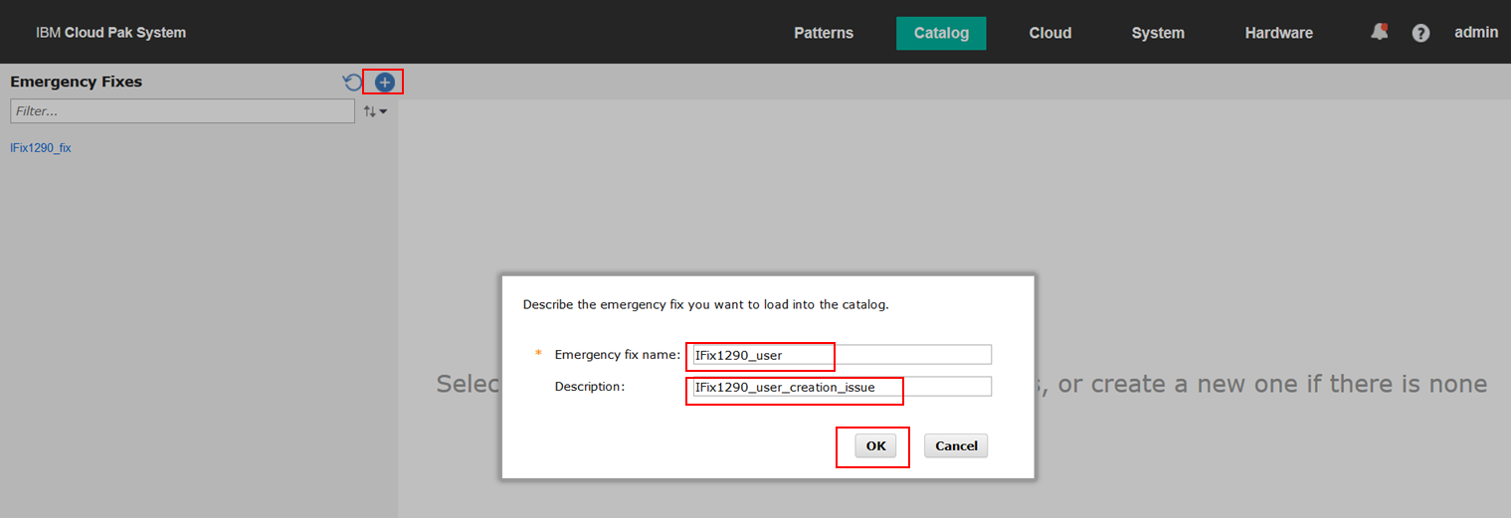

3) Browse the Emergency fix and click Upload.
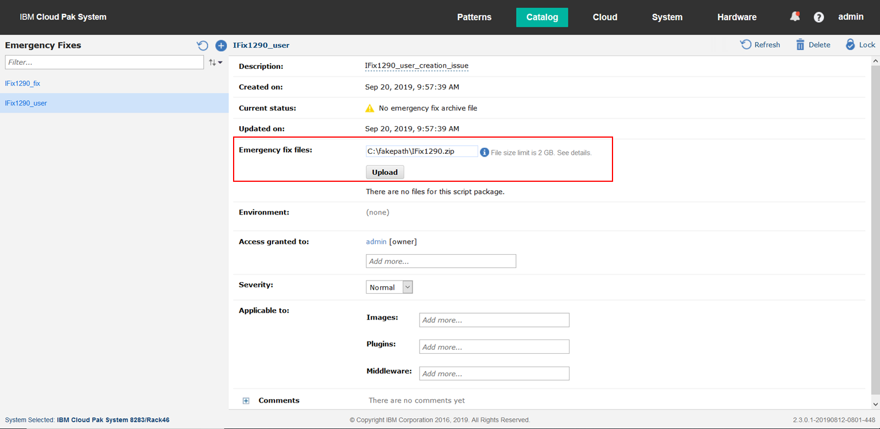
4) Select pattern.db2/1.2.9.0 from the plugins select box.
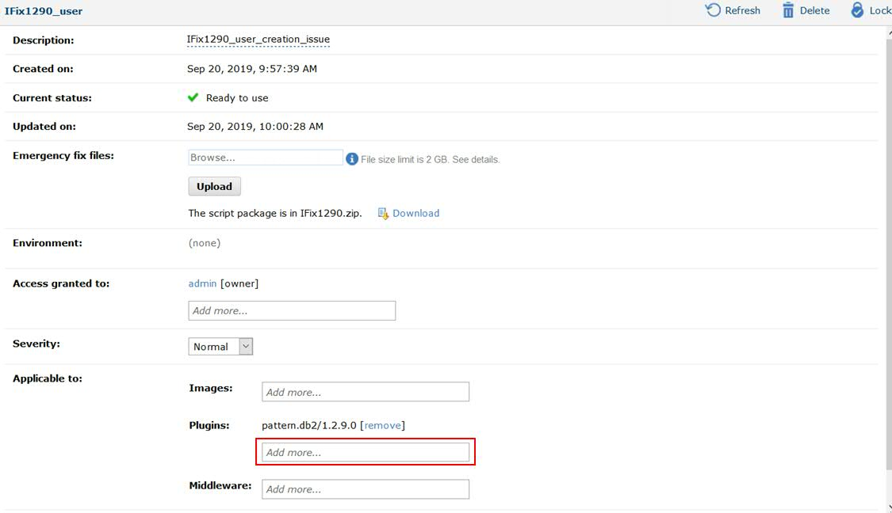

Steps to Install the IFix:-
1) Go to Instance console of the deployed instance. Click Operations Maintenance.
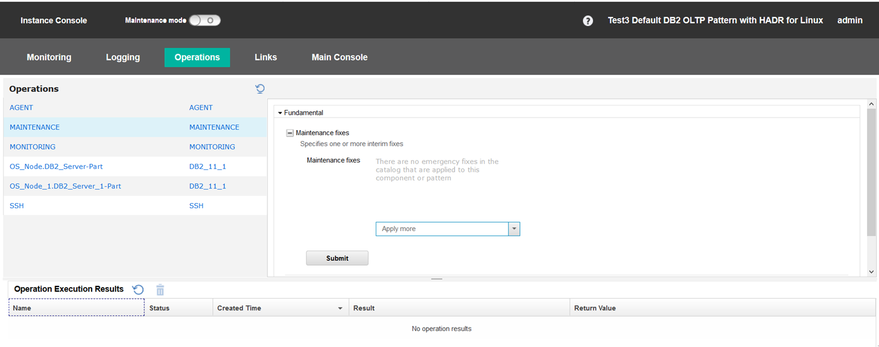
2) Under Maintenance fixes, select the uploaded IFix and click Submit.
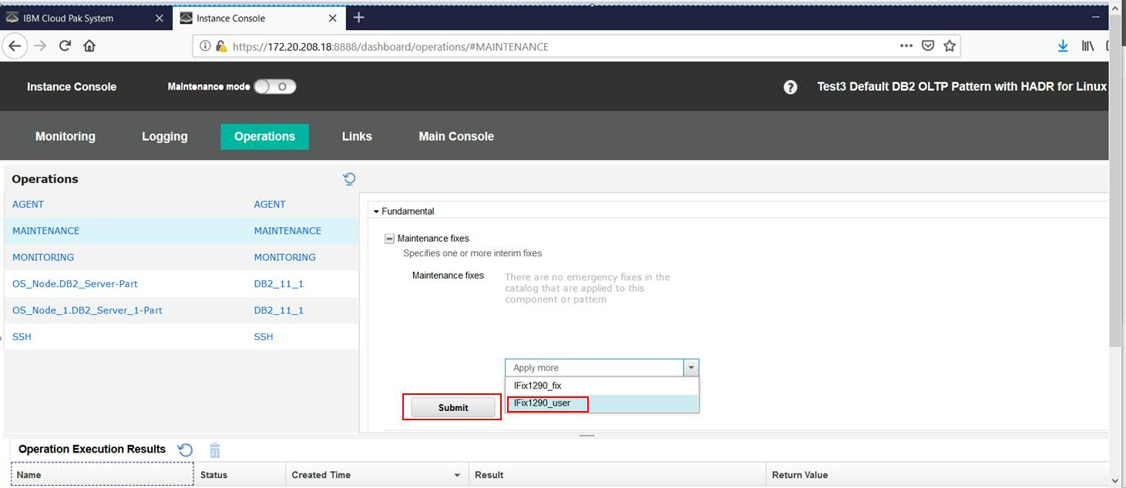
3) Once after IFix is installed, you can see the following successful message.
